Comprehensive Assessment

Q1.identify epic,user-stories and acceptance criteria

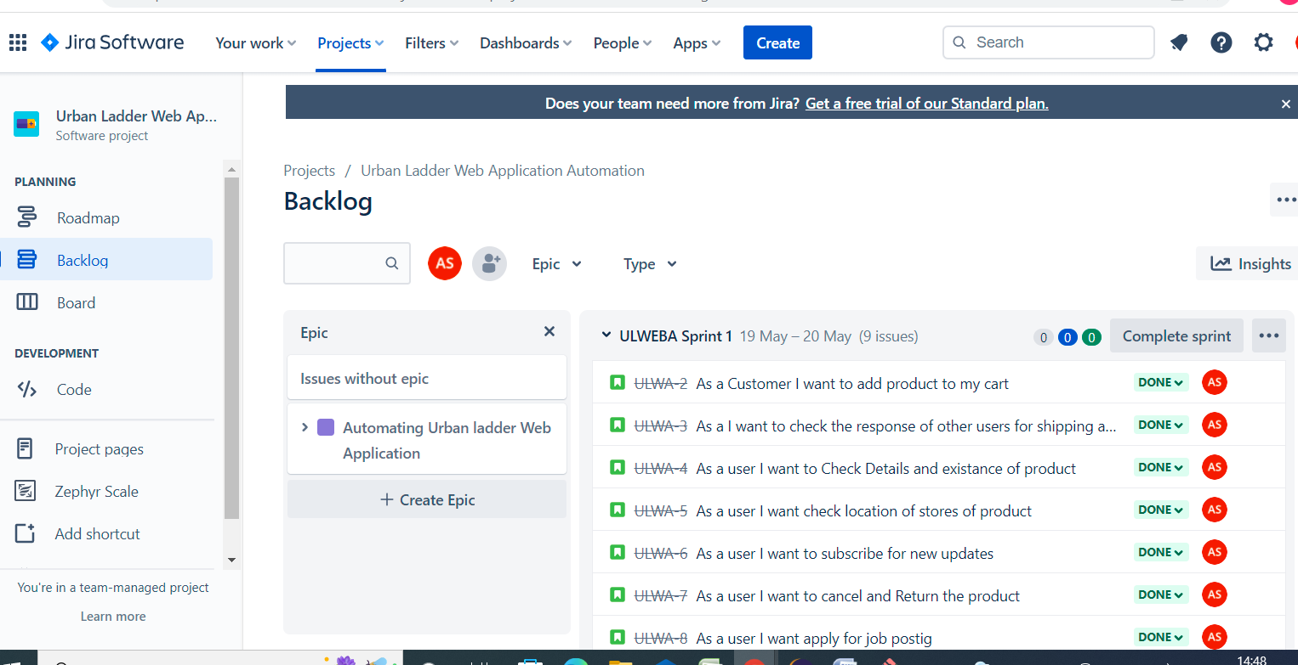

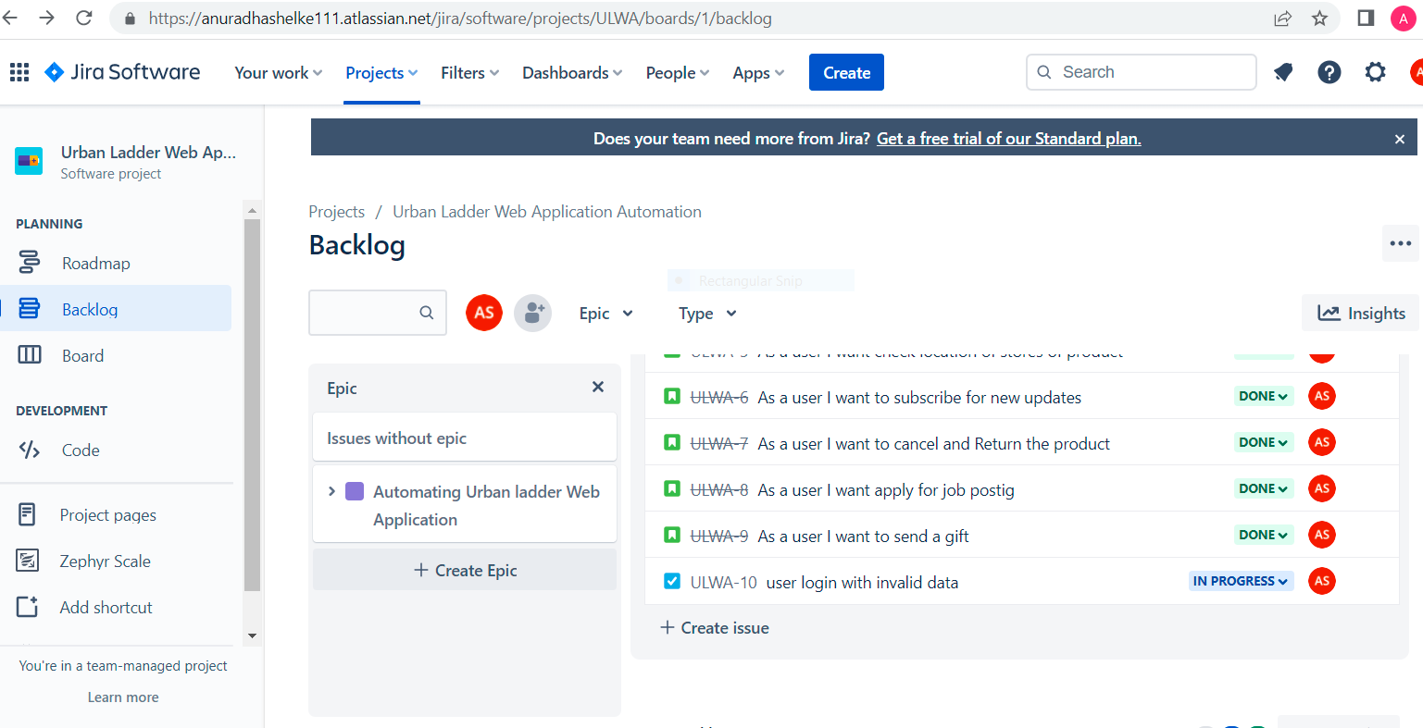

Q2.test plan and test strategy documents

1. Test plan document: Testing documents, Q2,Q3,Q4,Q8,Q9\test plan document.docs
2. Test Strategy document: Testing documents, Q2,Q3,Q4,Q8,Q9\Test strategy document.docs

Q3. Requirement Tracebility Matrix

1. Test Scenario document: Testing documents, Q2,Q3,Q4,Q8,Q9\Test Scenario.xlsx
2. Test Cases documents: Testing documents, Q2,Q3,Q4,Q8,Q9\checkoutTestCase,LoginPageTestCase,productDetailsTestCase,TestCases.xlsx

Q6. Git repository

1. Hybrid framework

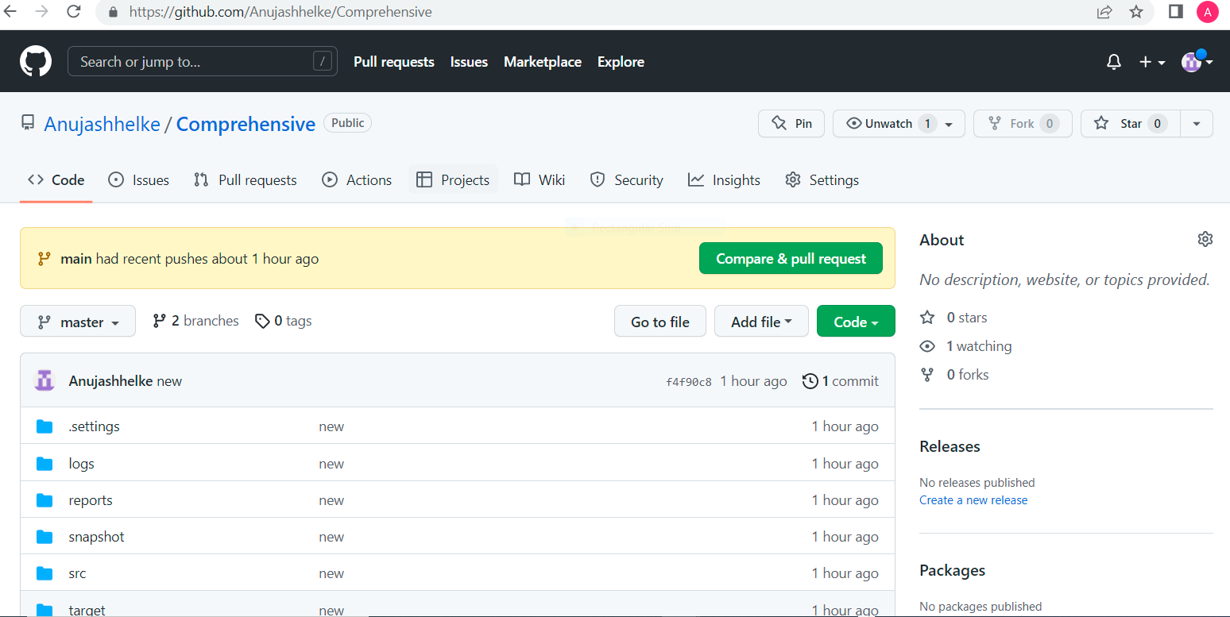

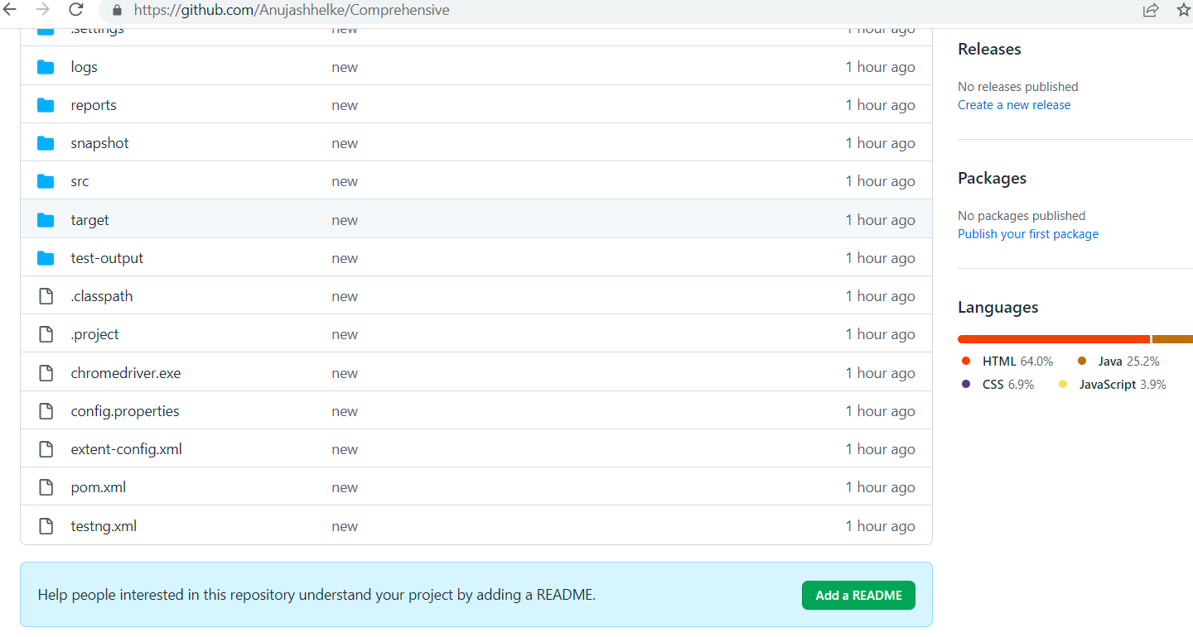

2)cucumber framework

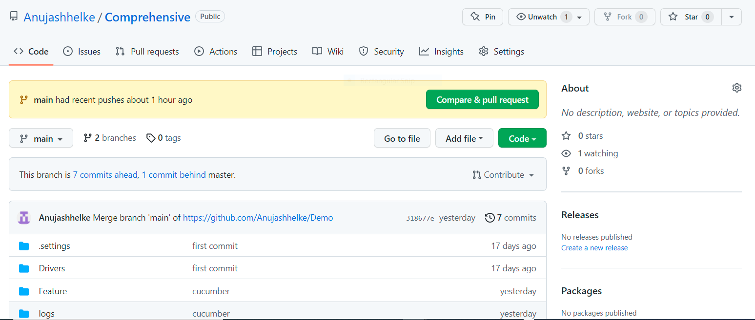

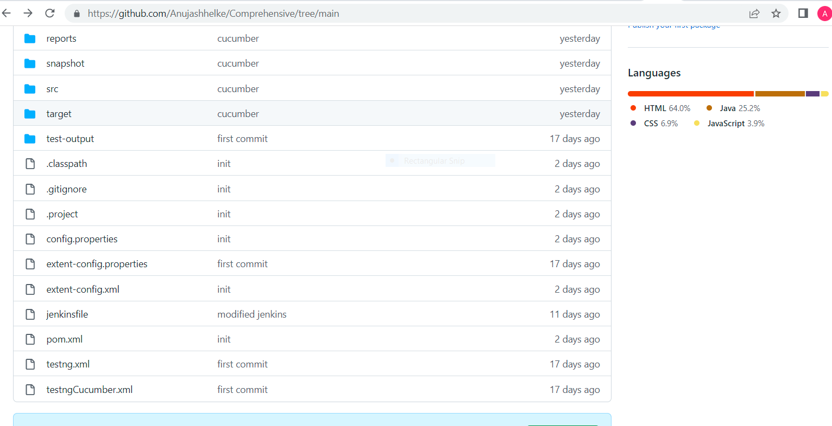

Git repository url=https://github.com/Anujashhelke/Comprehensive.git

Q7.configure Jenkins with git for continuous integration automation scripts for one framework.

[hybrid5.PNG](https://mindtreeonline-my.sharepoint.com/:i:/r/personal/m1084320_mindtree_com/Documents/hybrid5.PNG?csf=1&web=1&e=QvHGcC)

Q8 test summery report: Testing documents, Q2,Q3,Q4,Q8,Q9\Test_Report.xlsx

Q9. Bug Report: Testing documents, Q2,Q3,Q4,Q8,Q9\Bug_Rport.xlsx

WebServices

RestProject11.xml